E Track Summary and Insights(2020-2024)

Pre Survey(2020-2024) Insights:

1. What are your personal goals and/or expectations concerning your involvement in E-Track?

**Learning and Growth**: Participants aim to gain knowledge, experience, and skills related to entrepreneurship, startup development, business strategies, and networking.

**Building and Launching**: Many participants hope to develop, validate, and launch their business ideas or startups during the program.

**Networking and Collaboration**: A common goal is to connect with mentors, peers, and potential business partners to build relationships that could support their entrepreneurial journeys.

**Problem-Solving and Market Understanding**: Participants expect to identify customer needs, validate their business ideas, and learn how to effectively address market demands.

**Utilizing Resources**: There is a strong focus on leveraging the resources and support available through the E-Track program to maximize the chances of success for their business ventures.

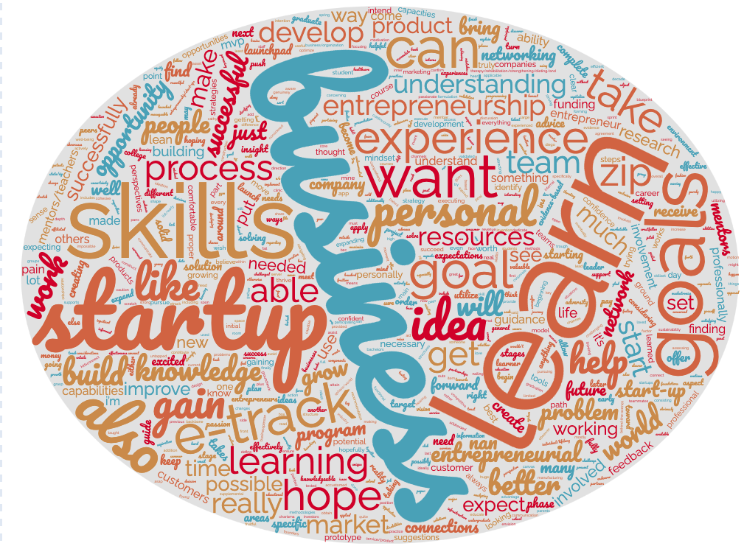

2. What are your personal goals and/or expectations concerning your potential future involvement in the ZIP Launchpad?

**Launching Startups**: Many participants aim to build and successfully launch their startups, utilizing the resources and support provided by ZIP Launchpad.

**Learning and Growth**: Participants expect to gain valuable entrepreneurial skills, experience, and knowledge, especially in areas like business development, market research, product design, and networking.

**Networking**: Establishing connections with mentors, peers, and industry professionals is a common goal, with many participants hoping to build relationships that will support their entrepreneurial journeys.

**Resource Utilization**: Participants plan to make the most of the resources, guidance, and opportunities available through ZIP Launchpad to achieve their business goals and personal development.

**Future Involvement**: Some participants express a desire to continue their involvement in ZIP Launchpad beyond their current projects, either by starting new ventures or contributing as mentors in the future.



Post Survey(2020-2024) Insights:

1. What are your personal goals and/or expectations after completing the E-Track?'

**Startup Launch and Development**: Many participants aim to launch or continue developing their startups, moving to the next stages like MVP creation or market introduction.

**Learning and Applying Knowledge**: Participants express a desire to apply what they've learned in E-Track to future business ventures, improve public speaking, understand entrepreneurship better, and make informed business decisions.

**Networking and Collaboration**: Building connections with mentors, peers, and potential team members is a recurring goal, with participants eager to expand their professional networks.

**Continuous Improvement**: Participants aim to refine their business ideas, strategies, and solutions, often with a focus on customer needs, market research, and data-driven decisions.

**Future Aspirations**: Long-term goals include creating multiple startups, pursuing additional entrepreneurial opportunities, and achieving successful business launches that make a meaningful impact.

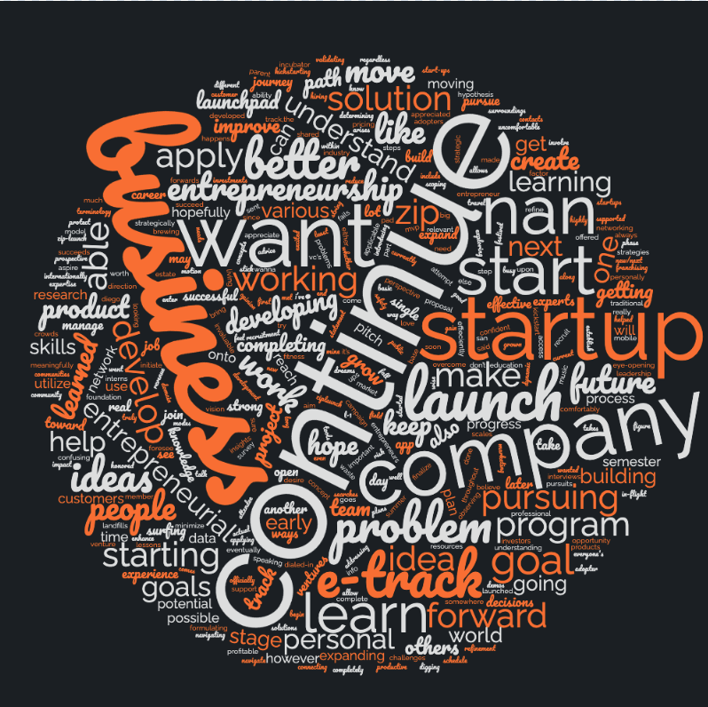

2.How have your personal goals and/or expectations concerning your potential future involvement in the ZIP Launchpad changed after E-Track?

**Increased Clarity and Confidence**: Many participants gained a deeper understanding of the importance of starting with a problem, gathering customer insights, and conducting thorough research before developing a solution. This has made them more confident and motivated in their entrepreneurial journey.

**Shift in Expectations**: Some participants realized the challenges of the lean startup methodology and adjusted their expectations accordingly. While a few found the process difficult to adapt, others became more excited and committed to continuing with ZIP Launchpad.

**Focus on Collaboration and Networking**: Participants recognized the value of collaboration, networking, and seeking guidance from mentors and peers. They plan to leverage these relationships to further their business ideas.

**Continued Involvement**: Most participants expressed a desire to continue their involvement with ZIP Launchpad, motivated by the support and resources they received. A few, however, are uncertain about their future involvement due to the challenges faced.

**Personal Growth and Learning**: The program helped participants grow as entrepreneurs, teaching them the importance of patience, perseverance, and being open to feedback. Many are eager to apply these lessons to their current or future startups.

